Project Report

By Carl Flynn

Requirement Specs

* The client asked for 4 pages (A Home page, about/information page, contact page and prices page)
* The home page should have a greeting, navbar at the top for easy navigation on all pages, and pictures of the hotel and facilities
* The about page should give info on location, facilities and what’s nearby
* Contact page should have all ways to get in contact and include an email form
* Prices page should include info on each room type and price per night of each and include a price calculator

Wireframes

Home Page

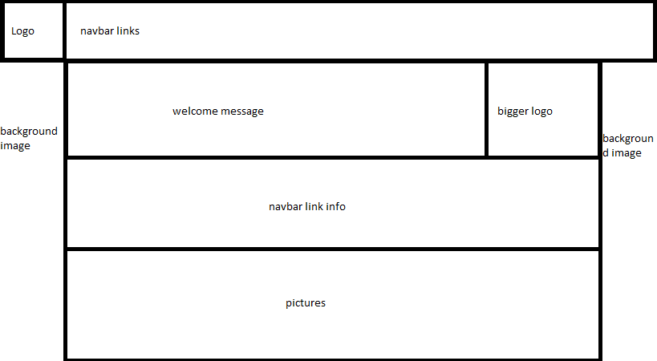

About Us/Information Page

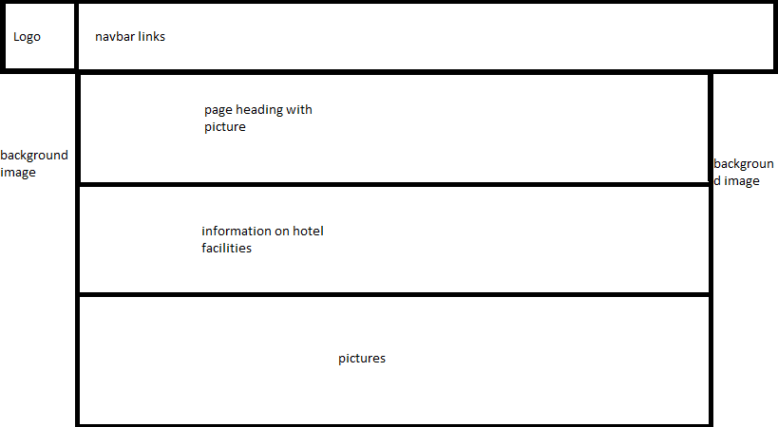

Contact Page

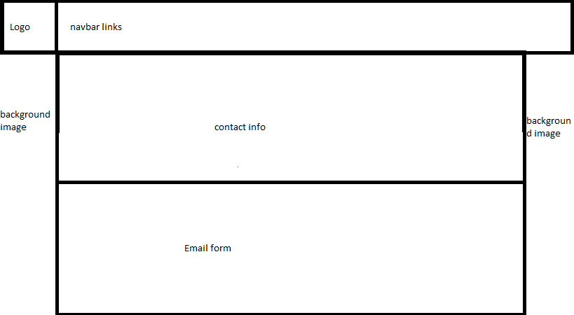

Prices Page

